 |  |  | 
 | Standard Operating Procedure (SOP)
 | Manage Product Technical Complaint and Suspected Falsification and Counterfeit
 | 115
 | Document Number: IQMS-97175
 | Version 15.0
 | Effective Date: | 2026-01-01
 | Applicability
 | Division: | CH, PH
 | Area(s): | Quality
 | This document is electronically approved (signatures on the last page)

Distribution Sheet for Quality Regulations
Division | CH, PH
Product Lifecycle Phase | Global Business Services, PH Biological Development, PH CPD, Manufacturing, CH R&D, Commercial Operation
Region/ Country* | Global
Product Group** | Cell & Gene Therapy products, APIs (incl. API starting materials, intermediates), Sterile drug products (incl. bulk and combination products), Biotech products, Medical devices, Food supplements (for human use), Cosmetics, Non-sterile drug products (incl. bulk and combination products)
Relevance for PH R&D | Shared Relevance PH R&D (Affected)

* Manufactured in or for region / country
** Regulation is distributed to each site that handles the product group

Lead Area: | Quality
Global Process Owner: | Andreas Joos (GBEDL)
Document Author(s): | Abhinav Srivastava, Andreas Joos, Angelina Huettmann, Bjoern Szotowski, Dorothee Langer, Gloria Gaviria, Helene Janzen, Jessica Krueger, Jesús del Vas Ropero, Mirja Kiiskinen, Ramin Shafii, Sylvie Soret, Torsten Kneuss
Process Group | Manage Quality Issue
Document level | Core process

Scope
This GSOP defines the process and quality requirements of how to “Manage Product Technical Complaint, Suspected Falsification and Counterfeit”.
It covers the handling, processing and reporting of:
- Product Technical Complaints (PTC), suspected falsification and counterfeit including external customers (i.e. third parties, who receive material from Bayer sites or buy APIs or intermediates, even those for already expired products)
- Product Technical Complaints associated with Adverse Events (PTC+AE)
It applies to:
- all complaints of products manufactured and/or distributed by Bayer AG, its subsidiaries or affiliates.
- all products placed on the market based on contracts for co-distribution, co-marketing and in-licensing as well as contract manufacturing.
Out of scope are:
- Product Technical complaints (PTC) and suspected falsification and counterfeit where BAYER is not the Marketing Authorization Holder (MAH) or the Legal Manufacturer. These cases have to be processed according to Quality Assurance Agreements (QAAs) in place.
- General statements on Bayer products that are not related to a Product Technical Complaint or Falsification & Counterfeit.
- Usability issues (Customer Satisfaction Issues and User Errors) for drug products, cosmetics, and food supplements.
- PTCs or suspected falsification and counterfeit where relevant product information is missing, such as brand names, configuration (presentation & strength) and the reporter cannot be contacted.

Abbreviations
AE | Adverse Event
API | Active Pharmaceutical Ingredient
CM | Case Management
CMO | Contract Manufacturing Organization
CoQ | Confirmation of Quality Request
CQH | Country Quality Head
CQU | Country Quality Unit
CRT | Central Receipt and Triage
FAR | Field Alert Report
GBS | Global Business Services
HCO | Health Care Organization
HCP | Healthcare professional
IMDRF | International Medical Device Regulators Forum
IUS | Intrauterine System
LODE | Lack of drug effect
LOE | Lack of effect
PV | Pharmacovigilance
PVCH | Pharmacovigilance Country Head
PQS | Product Quality Safety
PTC | Product Technical Complaint
QA | Quality Assurance
QAA | Quality Assurance Agreement
QVA | Quality Vigilance Agreement
QMS | Quality Management System
RPS | Relevant Production Site
RQU  UI | Responsible Quality Unit  Usability Issue

Definitions
For generic definitions see SUP 200 “Glossary”.
Adverse Event (AE) | Any untoward medical occurrence in a patient exposed to a medicinal product and which does not necessarily have a causal relationship with the medicinal product. An adverse event can therefore be any unfavorable and unintended sign (for example, an abnormal laboratory finding), symptom, or disease temporally associated with the use of a medicinal product, whether or not considered causally related to this medicinal product.
Product Technical Complaint (PTC)  (also encompassing Complaints according to ISO 13485) | Any report received (written, electronic or verbal communication) about a potential or alleged failure of a product in its quality [including the identity, durability, reliability, safety, efficacy or performance] or a suspected falsification and counterfeit which may or may not represent a potential risk to the patient / customer / user / environment.
Pharmacovigilance (PV) Case | Report which qualifies for capturing in the PV safety database. This includes  - reports of suspected adverse (drug) reactions (also referred to as individual case safety report (ICSR)),  - adverse events,  - invalid cases,  - medical device reports/incidents with potential health impact (i.e. malfunction reports with the potential to cause harm if the malfunction were to recur),  - serious undesirable effect (SUE) for cosmetic products and  - certain reports without adverse event referring to: special circumstances (e.g. exposure via parent, lack of drug effect (LODE), medication errors, (intentional) product use issue, off-label use, overdose, abuse, misuse, drug dependency, product use issue, pre-existing condition improved (in an unapproved indication) and occupational exposure).
PTC associated with Adverse Event (PTC+AE)  (also encompassing Medical Device Adverse Events and Medical Device Serious Adverse Events according to ISO 14155) | Any report of a PTC or usability issue (UI), which includes information of an adverse event or has been received or initiated in association with a single or cluster of PV cases or constitutes a medical device complaint with potential serious health impact fulfilling any of the following criteria:  - a PV case includes a reference to a potential or alleged product technical defect of the product,  - a PV case is related to a suspected falsification and counterfeit,  - a PV case or cluster of PV case report(s) questions the product quality by the reporter or PV (confirmation of product quality request),  - a PV case which refers to a medical device (regardless of incident category or life-cycle status),  - a PV case which refers to medical device constituent or component of a combination product as suspect product associated to potential or alleged technical or quality defect,  - any PTC constituting a medical device complaint with potential serious health impact even without AE or special circumstances e.g. malfunctions of a device-constituent part of a combination product which might lead to serious injury/death.
Confirmation of Quality Request (CoQ) | Reporter (patient, customer, healthcare professional (HCP), authority, investigator) as well as PV Representatives may raise a “confirmation of product quality request” due to:  - a request for confirmation of quality (example: health authority inquiry requesting quality investigation, etc.)  - fatal or life-threatening events and other alerting situations which are unexpected for product and patient health conditions in which there may be a suspicion of quality issues.  - unusual cluster or (batch)- signal of similar events  - Medical Device Reporting (21 CFR Part 4 Subpart B) [1]  General pre-requisites for a confirmation of quality request include at least one of the below (exception: critical safety/quality cases with a suspicion of causal relationship to product quality issue):  - Batch number  - Complaint Sample  - Monitoring observation, e.g. AE cluster detected by PV.
Incident  (EU MDR 2017/745 and IVD 2017/746) | Any malfunction or deterioration in the characteristics or performance of a device made available on the market, including use-error due to ergonomic features, as well as any inadequacy in the information supplied by the manufacturer and any undesirable side effect; and for in vitro diagnostic (IVD) devices, including any harm as a consequence of a medical decision, action taken or not taken on the basis of information or result(s) provided by the device.
Serious Incident (EU MDR 2017/745, MDCG 2024-4 and MDCG 2023-3) | Any incident that directly or indirectly led, might have led or might lead to any of the following:  - the death of a patient, user or other person,  - the temporary or permanent serious deterioration of a patient's, user's or other person's state of health, that resulted in any of the following  - life-threatening illness or injury,  - temporary or permanent impairment of body structure or body function,  - hospitalization or prolongation of subject hospitalization,  - medical or surgical intervention to prevent life-threatening illness or injury or permanent impairment to a body structure or a body function, examples of this can be:  - professional medical care or additional unplanned medical treatment,  - a clinically relevant increase in the duration of a surgical procedure,  - chronic disease,  - foetal distress, foetal death or a congenital physical or mental impairment or birth defect.  - a serious public health threat
Serious Public Health Threat  (EU MDR 2017/745) | An event which could result in imminent risk of death, serious deterioration in a person's state of health, or serious illness, that may require prompt remedial action, and that may cause significant morbidity or mortality in humans, or that is unusual or unexpected for the given place and time.
Lack of Drug Effect (LODE) / Lack of Effect (LOE) | Failure to produce the expected physiological / pharmacological action of a medicinal product or medical device for human use. The term LODE is synonym to the term Lack of Effect (LOE) if the mode of actions is not a drug substance as in medical devices.  LODE cases may be treated as PTC+AE. The decision is made by the responsible Pharmacovigilance unit.
Usability Issue (UI) | Use error or customer satisfaction issue of a medical device or the medical device constituent of a combination product are each a subgroup of usability issues.  - Use Error: Act or omission of an act that has a different result to that intended by the manufacturer or expected by the operator of the medical device or the medical device constituent of a combination product. Use errors include slips, lapses, and mistakes. An unexpected physiological response of the subject does not in itself constitute a use error.  - Customer Satisfaction issues: An expression of dissatisfaction by a customer/user, regarding a medical device or the medical device constituent of a combination product because there is no allegation that product fails to meet claims. Customer satisfaction issues include, e.g., handling problems, difficulties to understand or to follow the instructions, etc.
Falsification | Falsification covers:  - Any medicinal product with a false representation of its identity, including its packaging and labelling, its name or its composition (other than any unintentional quality defect) as regards any of its ingredients including excipients and the strength of those ingredients  - Manipulations of genuine product for instance but not limited to (1) changing variable data, (2) removing/exchanging content, (3) returned and resold used products  - Disappeared/Diverted Product: Genuine product rerouted out of its intended legal supply chain into another supply chain by unauthorized actions, irrespective of whether the second supply chain is legal or not  - Disappeared/Theft/Stolen Product: Genuine product taken without authorization from anywhere in the upstream or downstream supply chain (warehouse, transport means, whilst within transit), be it by use of force, threat of force (e.g., robbery), misappropriation (e.g., by personnel) or deception (e.g., fraud)  Remarks  Disappeared products in the sense of “a lost product”, meaning (in contrary to diverted or stolen products - see definition above) the accidental misplacing or disappearance of a product with the result that its whereabout is unknown at a specific time and, condition that there is not intent involved in the displacing or disappearance, are a separate category.  These incidents are processed as complaints (quantity issues).  Genuine product which is initially in doubt to be genuine and therefore reported as suspected falsification / counterfeit are processed as regular PTCs.
Counterfeit | Counterfeit covers:  - Trademark Violation: Product either using without authorization any or a combination of the following: tradename, trademark, icon, rights owned and protected by Bayer according to applicable legislation.  - Fraudulent products: “Products imitating a “generic” version of a genuine (Bayer) product by using any or a combination of the following (1) visual aspects of the original, (2) naming very close to the original or (3) claiming that the same API is present and independent of its registration status and true composition by excluding generic products with known legal registration status which belong to an identifiable MAH.”

Process Information

General Guidance for Managing Product Technical Complaint and Suspected Falsification and Counterfeit
Managing PTCs comprises the collection, documentation, evaluation and reporting of quality related information, plus respective escalation of potential critical issues to management functions and Health Authorities. This also includes the management of suspected falsification and counterfeit.

Complaint Classification
Product Technical Complaints and Suspected falsification and counterfeit are classified initially and finally after their evaluation. The classification is based on the company’s assessment of the nature of the case and the potential risk to patient / customer / user / environmental safety according to the following definitions:

Risk Classification ^{[8]} | Initial | Final
High | Complaints regarding potential defects which are potentially life-threatening or could cause a serious risk to health. | Complaints regarding defects which are potentially life-threatening or could cause a serious risk to health.
Medium | Complaints regarding potential defects which could cause illness or mistreatment with potentially non-serious medical consequences but are not classified as high | Complaints regarding defects which could cause illness or mistreatment with potentially non-serious medical consequences but are not classified as high
Low | Complaints regarding potential defects which may not pose a significant hazard to health. | Complaints regarding defects or alleged defects which may not pose a significant hazard to health.
Non-Justified | Not to be used | Non-defective product or the investigation did not confirm the alleged defect

For Radiology Medical device related complaints, determined to be Unconfirmed Quality Defect, the Final Risk Classification will be marked as non-justified. In alignment with the Radiology Risk Management Files, Severity Category will always depend on the final patient outcome associated with the complaints
Examples for each risk classification are listed in Annex 1: Examples for Risk Classification of PTCs.

Timelines
Complaint timelines are based on the depth of complaint assessment / investigation required. The “Total max timeline” (see table) is defined by the time required to complete all activities. After the initial notification of the GBS/CQU (date becoming aware/ awareness date) the duration of the complaint process adheres to the following time frame [in calendar days]:
Complaint process type | Complaint Initiation by GBS/CQU | Investigation¹ | Approval / Closure¹ | Total max. timeline
Standard | 5 (immediate escalation within 24 hours as required according to 5.1.2)^{4,5} | 20 | 5 | 30
Non-Standard² |  | 50 | 5 | 60
Local Closure³ | 30 | - | - | 30
¹ plus remaining time from previous step(s)
² Non-standard means
- a third party / CMO / external lab (service provider) is involved
- sample was requested but not received during data entry step within the required timeline.
- sample shipment is difficult
- an extension of investigation or testing is required (e.g. analysis at external laboratory, quality safety evaluation)
³ see section 5.1.1.1
⁴ immediate escalation necessary, e.g., for serious public health threats, potentially life-threatening cases, cases potentially requiring a FAR. For complaints involving Radiology Medical Devices, immediate escalation to RQU is necessary if complaints include allegations of Death, Air Injection or Extravasation
⁵ Complaints that do not have a batch number and photos, but complainant agreed to keep the sample, the complaint can remain in the initiated state until enough information is received for investigation. Once the necessary details are obtained, the awareness date should be updated to indicate when the minimum required information (batch number or relevant photos) for initiating an investigation is received, and a comment should be added to the communication protocol
The awareness date in the complaint database reflects the day that BAYER Quality function becomes aware of the initial complaint / follow-up information (follow-up complaint).
If an amendment of an existing complaint case is necessary, the awareness date remains the date when BAYER’s Quality function originally became aware of the issue.
Due date extension of a complaint is allowed, with interim report and justification, if complaints cannot be closed within defined timelines due to the nature of the test, e.g. for microbiological tests, or if third parties are involved (contract manufacturers). However, all complaints must be finally closed after 90 days at the latest based on the available information at that time.
If all complaint-related activities cannot be completed within 90 days (e.g., where the investigation includes third party and/or external service provider such as external lab and/or expanded over multi-sites), complaints remain open beyond 90 days and are considered overdue. GBS/CQU is notified about the current status.

Sample Handling
Any sample can serve as evidence in a legal case. Therefore, the handling must be done in a controlled manner. The loss of such sample can lead to potential liability or criminal sanctions.
If samples are received in an evidence bag, they remain associated with the original sample bag, and the integrity of the bag and its content are maintained. The chain of custody is always documented (in some cases directly on the evidence bag) so that it can be provided if and as requested by the authorities.
Any sample returned with a chain of custody is handled in a manner that maintains the integrity of the chain of custody established by the reporter. This is usually a government agency that will provide instructions to follow. Return sample shipments must be traceable through the logistics service employed.
If all necessary information (e.g., all variable data, any serialization code with its human readable information and texts printed on the product, etc.) can be provided by suitable electronic evidence (e.g., photo, video) or if shipment creates additional risks (e.g., safety hazard, biohazard), shipment of samples should be substituted by photo or video. The complainant is asked to keep the sample, if available, for at least 3 weeks. The RQU notifies GBS/CQU regarding sample requirement for investigation.
For IUSs BP 1429 “IUS Technical Complaints Guidance document” needs to be followed.
Complaint samples are retained for at least 3 months after completion of the investigation by the RQU, RPS or the CQU if investigation is not needed at the site if not advised otherwise by e.g., legal counsel for instance because they are needed as evidence in legal proceedings. Upon request of legal counsel, the samples are sent to the designated internal function or any other assigned external lawyer, investigator, or person. There the samples are stored as long as deemed necessary by legal counsel.
Complaint samples received from the market via Bayer Affiliates are no longer customer property, as the affiliates are responsible for the compensation of the property. The complaint samples will not be returned to the complainants (except request for legal cases).
In case a destructive testing of the complaint sample is planned regarding a serious incident of a medical device: The competent authority is informed as part of Manufacturer Incident Report (MIR) prior to the planned testing as needed.

Final classification of Complaint cases
Terms | Definition
Confirmed quality defect | The initial complaint (alleged quality defect, issue, error) could be confirmed, and the root cause of the confirmed quality defect is within Bayer responsibility.
Unconfirmed quality defect | The complaint (alleged quality defect, issue) is unconfirmed, or root cause of the confirmed issue is not within Bayer responsibility.
Unconfirmed quality defect, but plausible | The alleged quality defect / issue can neither be confirmed nor ruled out by the RQU to be within Bayer responsibility, but a quality issue is considered plausible.

Product and case specific requirements:
- For combination products registered as medicinal drugs the rules of complaint handling for medicinal products must be followed. Product specific requirement needs to be considered.
- Any product specific procedure for handling technical complaints must be approved by the divisional Quality Function and documented.
- The complaint process for specific low risk Consumer Health products (i.e. cosmetic and food supplements) follows risk-based approach. A single case evaluation is done at RQU level to determine the need of investigation based on pre-defined criteria (see below). Investigation is mandatory and whenever considered relevant, if:
  - Initial risk classification “high” or “medium"
  - Complaint involves Health Authority
  - Suspected falsification and counterfeit, if sufficient information to perform an investigation is available (i.e., sample and/or pictures)
  - Confirmation of Quality Request reported by HCP, Authorities or PV
  - RQU detects specific trend (e.g., for a batch, specific issue, country, error code)
  - Signal/Trend detected during periodic review in accordance with GOI 1172 “Perform Periodic Review of Complaints including Quality checks”
  - Investigation is mandatory if required by local regulation

Process Flow

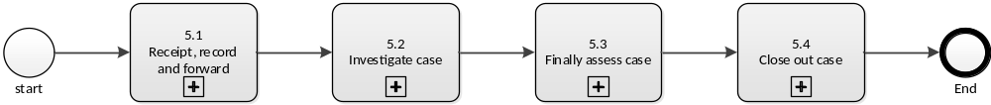

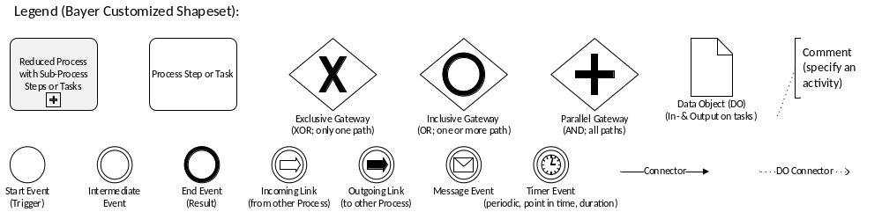

Assigned Roles and Responsibilities
Global Business Services (GBS), legal entity of BAYER AG | - Performs initial assessment at date entry, documentation and according to defined timelines  - Manages communication, sample handling, and case closure ensuring completeness, accuracy, and regulatory compliance, if applicable.  The responsibilities of the GBS can be also performed by the Country Quality Unit (CQU), if not transferred.
Country Quality Head (CQH) / Country Quality Unit (CQU) of the legal entity which introduces product into market (e.g. Marketing Authorization Holder, Distribution license holder) | - ensures the appropriate handling of PTCs, and suspected falsification and counterfeit, reported in the respective country including the timely execution of the related activities, particularly for the entry of the cases into the complaint database, forwarding them and for responding to the complainant.  - fulfills all obligations, e.g., PTC related reporting requirements defined by legislations or regulations.  - Oversees and monitors the whole PTC process for products on market of their legal entity in case of delegation to GBS, e.g., by controlling appropriate Key Performance Indicators according to GSOP 1372 “Perform Country Quality Management Review”
Pharmacovigilance (PV) roles: PVCH, CM / CRT / CM PQS | - PV ensures that GBS/CQU is informed of PV cases qualifying for a PTC+AE and provided with all relevant PTC information  - For PVCH only: forwards PTC + AE to relevant stakeholder  - For CM / CRT only: Records PTCs received from GBS/CQU that constitute medical device complaints with potential health impact, even without an AE or special circumstances
Divisional Quality Function | For PH: PH-PS Quality  For CH: CH Quality  - ensures that the tasks pertaining to the complaint handling process and suspected falsification and counterfeit are fulfilled and that the described responsibilities are assigned to functions within the organization.  - ensures that for each marketed product a Responsible Quality Unit (a quality unit that released the product onto the market, or a central service function, e.g., for a particular region or for products produced and released by contract manufacturers.) is available.
Gatekeeper (GK) | See GSOP 117 “Product Quality and Safety Committee (PQSC) - Charter”.
Responsible Quality Unit (RQU) | - Reviews, classifies, and investigates complaints, ensuring complete documentation, timely actions, and coordination with all relevant stakeholders.  - Ensures implementation of corrective and preventive actions and provides final assessments and communication to relevant functions.
Relevant Production Site (RPS) | - Ensures timely investigation and documentation (including root cause analysis), retention of relevant complaint samples, and implementation of necessary corrective and preventive action

Detailed Process Description

Receipt, record and forward case

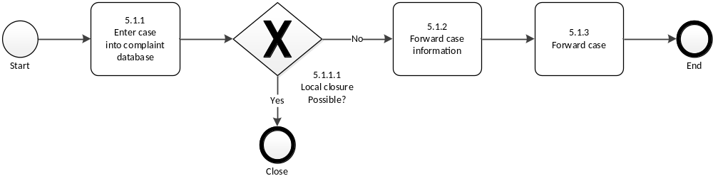
Description including document reference | Assigned Roles
Enter case into complaint database  - Perform the initial assessment of complaints after receipt and file each case as summarized in section 4.1.1 in the complaint database in English language within the required timeline (see 4.1.2).  - Screen, if the case represents a serious public health threat, is potentially life-threatening or requires a FAR and escalate immediately according to 5.1.2.  - Ensure completeness and accuracy of the information (including the photo or video, if available from the complainant) and add all available documentation (also documents in local language). Ensure translation of non-hosted languages  - Update the complaint database regarding sample flow/status and notifying the CQU (if GBS is involved) when sample retrieval is required  - Provide instructions to the complainant on further sample processing, e.g., instructions to send the sample directly to the RQU or CQU  - Use Annex 2: Pick list for Reporting Suspected Falsification and Counterfeit to facilitate and harmonize reporting on suspected falsification and counterfeit.  - Perform up to 3 documented attempts in the complaint database to obtain missing or insufficient relevant information such as batch number, applied serial numbers for suspected falsification and counterfeits and the complaint sample required for the complaint investigation unless justified why less or even no attempt was made, e.g. if a sample is declared not to be available.  - Process medical device and combination product complaint with potential health impact (Serious Public Health Threats, Incidents) as PTC+AE to ensure that a device report can be submitted to Competent Authorities and the responsible Notified Body via the global safety database as needed.  - Process all Radiology Medical Devices complaint cases, i.e. PTC, PTC with AE and AE cases in the complaint database only and not in the safety database.  - Enter usability issues into the complaint database, even those with no report of a suspected quality defect.  - Process use errors as PTC+AEs if they are associated with a PV case, i.e. reported AE or special circumstances, e.g. off-label use, misuse, medication error.  - Process LODE cases as PTC+AE if PV raises a confirmation of product quality request  - Determine if a technical investigation is necessary. If not, provide justification.  - Send an acknowledgement letter, if required, to the complainant using a template defined in local SOP.  - Notify the legal manufacturer of a device and where necessary, the manufacturer's authorized representative and the importer, if applicable.  Remarks:  - Country of Event /Incident is related to the country where the complaint is reported  - First attempt to retrieve the samples / pictures / batch number associated with the complaint is completed and documented within 5 days of complaint information receipt. After first attempt is completed, complaint is forwarded for assessment, only if:  - Sample has been shipped by the customer; or  - sample has been indicated to be available, but first attempt was unsuccessful in retrieving the sample, but pictures were provided; or  - Batch number has been provided by the complainant / reporter and included in the complaint database  - If the complaint database is not available, the data is entered as soon as the database is available again.  - Personal Data are only entered with a distinct purpose, e.g., retrieval of sample or providing a response to the complainant and if permitted by local law.  - Bundling of cases is only acceptable for  - Suspected falsification and counterfeit, e.g., due to test purchases or serialization alerts with initial classification low, if they are related to one single product, one single batch and one single country (multi-country pack located in "EU" is considered as one country) received on the same day (see also GSOP 1581 “Process EU FMD Alerts”).  - Social media triggered complaints or complaints from Marketing studies, e.g., related to the same defect, received in a short time frame, by one single country, assessed as unconfirmed quality defect and in alignment with the divisional quality function.  - Such bundled cases are handled in the following way:  - Cases are collected in the complaint database under one case for one product with a short description by the GBS/CQUs for social media triggered complaint or Alert Operators for Suspected Falsification and Counterfeit. To conduct this the alert operator creates an entry in the Complaint Management System daily and forwards the case to CQU/GBS. This allows appropriate trending and signal detection. | GBS/CQU
Local Closure possible?  - Only for cases associated with  - Usability Issues or  - Documentation or  - PTC or suspected falsification or counterfeit,  - where  - legal manufacturer was informed or  - no complaint sample is available and  - no photo of the sample can be sent and  - no batch/serial data of the drug product or medical device have been reported after three documented attempts and  - no AE was reported  include the rationale for local closure provided that three documented attempts were made to obtain the sample and the necessary information or sample is already declared not available.  - Trademark violation or Fraudulent Generic if confirmed that the product is not a Bayer product/produced by any Bayer site/third party on behalf of Bayer.  Remarks:  - For complaints closed locally, classify complaint case using risk classification according to its criticality (see 4.1.1) | GBS/CQU
Forward case information  - Forward the respective information to PVCH immediately, if a PTC or a suspected falsification and counterfeit includes information of a (potential) PV case / Adverse Event / LODE.  - Forward the respective information to PVCH immediately about medical device complaints with potential serious health impact including the unique complaint database case number and all relevant follow-up information (e.g., batch number).  - Escalate immediately to divisional Gatekeeper if the case is considered to be potentially life-threatening or could cause a serious risk to health or required by local law.  - Inform the CQU immediately if  - a PV case involves a PTC or  - a confirmation of quality request (CoQ) is raised by an external (e.g. health authority) or internal (e.g. monitoring observation) function and provides all available relevant case information  - local authorities are involved in PTCs  - potential falsification and counterfeits are reported as applicable  - Forward PTC-related information including suspected falsification and counterfeit to local authorities, if required by local law.  - Assess the reportability of a medical device complaint and the reporting of medical device cases to authorities, Notified Bodies, 3rd party legal manufacturers itself out of the global safety database (see GOI 1034 “Manage reportable medical device complaint”)  - Assess the reportability of a constituent Part of Combination product and the reporting of cases to FDA out of the global safety database (GOI 1034)  - In case of suspicion of falsification and counterfeit incidents falsification and counterfeit inform corporate security if required by local law  Remarks:  - Radiology Medical Device MDR reporting is done independently to the complaint database.  - Local timelines must be considered, e.g., for FAR reporting in the and for potentially critical complaints where the affected batch(es) is/are distributed to more than one country, even if the investigations have not been finalized.  - For approved biological products distributed in the US, a Biological Product Deviation Report is submitted per CFR 600.14 not to exceed 45-calendar days from the date a reportable event has occurred.  - For EMA centrally authorized medicine, including suspected defects, an EMA DPR (“Defective Product Report” Process to Report a quality defect of a centrally authorized medicine, including suspected defects, to EMA) is submitted for quality defects and a “(Suspected) falsified medicinal product report” is submitted for falsifications. | GBS/CQU  GBS  CQU  PVCH  PV
Forward case  - Forward the complaint to next step, if pre-requisites for local closure are not met as defined in chapter 5.1.1.1.  - Contact the RQU for further instructions in case of doubts whether the sample must be shipped or not.  - Forward all samples and/or pictures capturing relevant details without undue delay and according to defined timelines for investigation to the Responsible Quality Unit  - Organize the shipment of the complaint samples including package and labelling in accordance with pertinent safety and regulatory requirements  - Forward any relevant follow-up information on complaints to the RQU and to the PVCH in case of a PTC+AE. | GBS/CQU

Investigate case

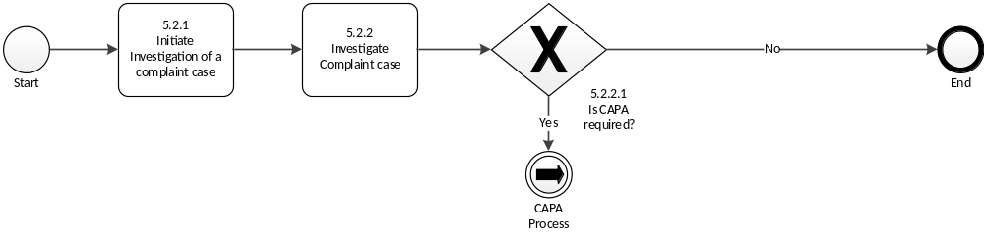
Description including document reference | Assigned Roles
Initiate investigation of a complaint case  - Assess initial PTC case for correctness, completeness of information or send it back to the GBS/CQU for correction, if necessary  - Assign initial Risk Classification according to its criticality (see chapter 4.1.1)  - Assign or update initial error codes  - Notify GBS/CQU regarding sample requirement for investigation (sample needed / not needed)  - Initiate and coordinate the investigation and evaluation of the complaint, if necessary, with support of other production sites involved in the manufacturing, packaging or release of the product, including contract manufacturers where applicable.  - Escalate case immediately (if not already done before) to the divisional Gatekeeper, if case is potentially life-threatening or could cause a serious risk to health.  - Prioritize the investigation of cases classified as “medium” and “high” striving to complete investigation as soon as possible  - Notify the legal manufacturer of a device or the manufacturer's authorized representative and the importer, if applicable according to the established QAA/QVA, if needed  Remarks:  - Initial review by RQU and the assignment of the initial risk class should be performed within three days after receiving the task  - GBS/CQU is informed via a report, if initial risk classification is “high” or “medium”.  - No investigation is required for usability issues for product incidents that have been determined to be the result of use errors and/or customer satisfaction issues and are known, unconfirmed issues. However, if there is an associated PV case that is directly related to the Usability Issue, the case must be entered into the complaint database as a single case (unless a product specific agreement for an alternative process has been agreed).  - For all new medical devices and combination products incoming cases are reviewed for a period of time after launch (timelines are defined by responsible Divisional Quality Function) to identify specific Usability Issue categories. These reviews are formally documented to justify inclusion as a Usability Issue.  - When a specific complaint reason is well understood (i.e., the root cause including potential CAPAs and associated risks could be identified during the investigation of a previous complaint on the same batch), a reference to an investigation already performed can be used for a given batch of product and a specific complaint reason. An investigation report is prepared by the RQU for the first complaint received for that batch and kept in the complaint database under the first complaint case initiated. The investigation report of the firstly reported case is utilized for additional complaint cases handled under separate case numbers for this particular batch and complaint reason.  - Prerequisites to investigate as described above:  - The complaint type is an initial risk classification of low.  - The investigation is for a specific PTC type (e.g. adhesion) and an individual batch number.  - The investigation of the first case of a batch is not older than 6 months unless a plausible justification is provided why no new investigation must be requested or a pre-defined threshold is not exceeded. | RQU
Investigate complaint case  - Perform an adequate level of investigations (including root cause analysis if applicable) in a timely manner  - Review executed batch record, testing and/or release documentation, as appropriate, which covers but is not limited to:  - in-process control results (IPCs)  - calculation of intermediate and final yield(s)  - out of specification (OOS) results  - (other) events or deviations  - cleaning processes, line clearance, monitoring results of routine cleaning process  - environmental monitoring results  - results of visual inspection  - any associated relevant documentation related to the production of the specific batch such as cleaning records, calibration records, maintenance of equipment.  - In case of suspected falsification and counterfeit: safety features and applied serial numbers. For the EU market their status and event information is retrieved from the National Medicine Verifications Systems (NMVS) and made available through the European Medicines Verification System (EMVS) and/or the internal status is retrieved via the internal global serialization database (ATTP=advanced track and Trace for pharmaceuticals). For other countries the status information is retrieved by a portal, web interface, webpage or application or similar, depending on which tool is made available.  - Investigate and/or assess raw material, starting material and packaging material, if necessary  - Investigate complaint sample by visual inspection and chemical, physical or microbiological analysis according to Annex 3: Decision tree for handling complaint samples  - Investigate retain samples by visual inspection of reference and retention sample (a justification is provided if visual inspection is not performed) and chemical, physical or microbiological analysis of reference samples as appropriate  For suspected falsification and counterfeit cases follow instructions in form SCEF (Template: Falsification and Suspected Counterfeit Evaluation form, IQMS-110229) to be mandatory filled for such cases if pictures and or samples are available unless rationale is provided, such as when the submitted pictures are not meaningful or when the incidents refer to repetitive cases.  - Determine a root cause according to Supplement 1728 “Root Cause Classification”  - Implement necessary corrective and preventive actions  - Assess the potential impact on other batches or products  - Review previous quality defect reports (with the same batch number or for the same product) for any indication of recurring problems requiring attention  - Assess for Medical Devices or Combination Products whether a usability error can be confirmed  - Maintain, either by referring to an ID of an established system or by adding the documents to the case, all documents generated with regard to the complaint investigation, sample analysis and assessments  Remarks:  - If a suspected falsification and counterfeit case is investigated by a third party an alternative process than the SCEF may be followed preconditioned that sufficient details to confirm or exclude a falsification and counterfeit are included in the investigation report.  - Testing is designed to confirm the quality of the product/batch by data. | RPS, QC, RQU
Is CAPA required?  - In case of a confirmed quality defect, determine CAPAs according to GSOP 356 “Manage Corrective and Preventive Action (CAPA)”  - If no, justify why CAPA is not required in case of confirmed defects | RQU

Finally assess case
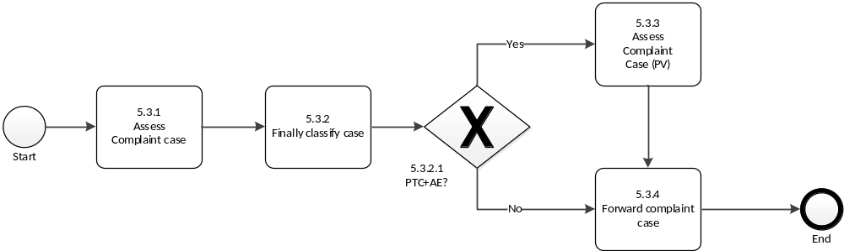

Description | Assigned Roles
Assess complaint case (Q)  - Ensure that adequate investigations are performed in a timely manner and that it is documented appropriately in the complaint database in English language.  - Ensure the completeness of investigation and request additional investigation, if needed.  - Ensure that a root cause or potential root cause has been identified.  - Assess the complaint regarding the alleged quality issue, performance issue, usability issue or falsification and counterfeit incident including confirmation or non-confirmation of a product quality defect in the complaint database according to the definitions in chapter 4.1.4.  - Assess the potential impact and risk posed by the quality defect based on its severity and extent.  - Review for all device cases where BAYER is the Legal Manufacturer whether the event and its frequency of occurrence is anticipated or not according to the device risk management file and relevant FMEAs.  - Assign the defect category and (most probable) root cause for confirmed and unconfirmed but plausible cases.  - Provide and document rationale in case use errors have occurred.  - In case an investigation has been performed, review and approve investigation report.  - For Pharma: For Medical devices and Combination Products (device constituent part affected) enter the respective IMDRF codes for cases with potential serious health impact into the complaint database  - For Consumer Health: For cases with potential serious health impact IMDRF codes are evaluated jointly between Quality and Pharmacovigilance functions.  Remarks:  - For Radiology a “confirmed quality defect” is selected when a CAPA has been initiated.  - For Radiology FDA codes are entered on electronic submissions to the FDA and are not subsumed in the complaint database. | RQU
Finally classify case  - Assign the final risk classification according to chapter 4.1.1.  - Escalate case to the divisional Gatekeeper, if at any time during the investigation the results indicate a quality issue with classification “high” or “medium” or if confirmed falsification is detected in the regular supply chain via the complaint database.  - Inform GBS/CQU via notification (communication protocol), if final risk classification is “high” or “medium”. | RQU
PTC+AE?  - If yes, assess if case must be forwarded for Quality Safety Evaluation after conclusion of the technical evaluation to PV. Provide sufficient time before closure, i.e. at minimum, 1 working day for final risk classification “High” cases, 3 working days for final risk classification “Medium” cases and 5 working days for final risk classification “Low” cases.  - If not, proceed with 5.3.4  Remarks:  - For cases that are considered as PTC+AE, those must be forwarded to PV for Quality safety Evaluation, if  - Conclusion is confirmed quality defect or unconfirmed quality defect but plausible  - Confirmation of Quality Request is raised  - Suspected falsification and counterfeit are reported  - Conclusion is unconfirmed quality defect and medical device or combination product (device part is affected) is involved  - Unconfirmed quality defect (with new significant information to be added/updated, i.e. correction of batch number or suspect product, handling error identified) | RQU
Assess complaint case (PV)  - Complete quality safety evaluation regarding the potential correlation between a confirmed or plausible technical defect or use error and the reported Adverse Event. | CM PQS
Forward complaint case  - Forward the complaint for final verification and closure to the GBS/CQU according to the defined timelines see chapter 4.1.2.  Remarks:  - In case of confirmed falsification and counterfeit respective functions within the organization are informed. | RQU

Close out case

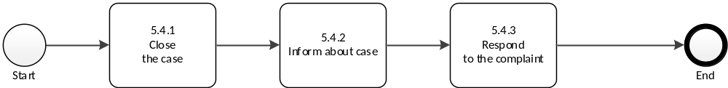

Description | Assigned Roles & Document Reference
Close case  - Finally verify investigation report regarding completeness and comprehensiveness after becoming aware of the case according to timelines in chapter 4.1.2  - Ensure completeness of all case related documents either attached to the case or by reference to further record keeping storage places.  - Close the complaint case in the complaint database  Remarks:  - If new information is received after closure of the complaint case that changes the outcome of the investigation a follow-up complaint must be initiated (i.e., sample received which was not available initially, patient outcome has changed) and the clock starts again (with new awareness date) according to the timelines in chapter 4.1.2.  - In case a Field Alert Report (FAR) is submitted, the divisional Quality Function provides the information for referencing the FAR in the investigation report as well in the complaint database.  - Complaints are amended only for corrections or to add pertinent information related to the complaint after its closure, e.g., email from a health authority closing an incident, revised response letters. Reopening must be requested to and approved by QA.  - Deletion of personal data in closed complaint cases is handled by the complaint process change control, if requested by the complainant / reporter. | GBS/CQU
Inform about case  - Ensure that in coordination with Regulatory Affairs information of complaint case is forwarded to authorities according to local requirements and timelines and in alignment with PQSC if applicable.  - Inform all immediate trading partners as required by the “Guidance for Industry on Drug Supply Chain Security Act Implementation: Identification of Suspect Product and Notification” not later than 24 hours after making the determination | CQU
Respond to the complainant  - If requested by authorities or individual complainant (e.g., HCOs, HCPs) or required by local regulations:  - Ensure that a written response is provided in a clear comprehensible form including a company evaluation and a statement concerning the root cause of the defect, if available. Consult other functions if applicable  - Consult the PVCH to ensure a coordinated response is provided for PTC+AE.  - Document and maintain all correspondence regarding the response in the complaint database or other cross-referenced system.  Remarks:  - The response does not consist of copies out of the complaint database. | GBS/CQU

External References
[1] | 21 CFR 4.100 – 4.105 - Postmarketing Safety Reporting for Combination Products
[2] | 21 CFR 211.198 – Complaint files.
[3] | 21 CFR 600.14 - Reporting of biological product deviations by licensed manufacturers
[4] | 21 CFR 820.3 – Quality System Regulation - Definitions
[5] | 21 CFR 820.198 – Complaint files.
[6] | 21 CFR 1271.320 – Complaint file
[7] | FDA Guidance for Industry on Drug Supply Chain Security Act Implementation: Identification of Suspect Product and Notification, June 2021
[8] | EU GMP Guide, Part 1, Chapter 8 “Complaints and Product Recall”, 13-08-2014
[9] | REGULATION (EU) 2017/745 OF THE EUROPEAN PARLIAMENT AND OF THE COUNCIL of 5 April 2017 on medical devices incl. all amendments
[10] | Directive 2001/83/EC on the Community code relating to medicinal products for human use
[11] | REGULATION (EU) 2017/746 OF THE EUROPEAN PARLIAMENT AND OF THE COUNCIL of 5 April 2017 on in vitro diagnostic medical devices and repealing Directive 98/79/EC and Commission Decision 2010/227/EU
[12] | CM/Rec(2024)3 - Recommendation of the Committee of Ministers to member States on reporting of disappearances of medicinal products for human and veterinary use from the legal supply chain (Adopted by the Committee of Ministers on 10 April 2024 at the 1495th meeting of the Ministers' Deputies)
[13] | Recommendation CM/Rex(2024)3 of the Committee of Ministers to member States on reporting of disappearances of medicinal products for human and veterinary use from legal supply chain
[14] | MDCG 2024-4 Safety reporting in performance studies of in vitro diagnostic medical devices under Regulation (EU) 2017/746, April 2024
[15] | ISO 13485:2016 Medical devices – Quality management systems – Requirements for regulatory purposes
[16] | ISO 14155:2020 Clinical investigation of medical devices for human subjects – Good clinical practice
[17] | EMA/INS/GMP/35037/2017 How to use the defective product report to notify a  quality defect to European Medicines Agency
[18] | MDCG 2023-3 Rev.2 Questions and Answers on vigilance terms and concepts as outlined in the Regulation (EU) 2017/745 and Regulation (EU) 2017/746, January 2025

History of changes

Version | Significant changes with respect to previous version | Effective date
Previous  Versions | See previous Version | See previous Version
115-13 | - Animal Health deleted from scope  - Update to Annex 4  - Inclusion of content from SUP 1635 “Handling of Product Technical Complaints samples” – Suppl 1635 set obsolete  - Reference to Supplement 1636 “RQU Investigation Form for reportable Medical Device Incidents” added.  - Introduction of bundling for social media complaints  - Removal of requirement to send PTC samples, when other media such as photos are sufficient  - Extension of data entry timeline, if neither sample nor batch is available for RC III & IV  Guidance for internal complaints if countries/sites are performing repackaging activities or visual inspections | 2022-09-01
115-14 | - Process adaption due to migration from Dev@Com into IQMS  - Chapter 4.1.1 and Annexes Complaint classification revised  - Timelines (chapter 4.1.2) adapted  - Initial risk classification task shifted from GBS/CQU to RQU  - Wording refined regarding Falsification and counterfeit incidents including adaption of definitions  - Shared Service Center changed into GBS  - Annex 4 Picklist completely revised and simplified  Supplements 1636 and 1582 set obsolete since reporting is conducted by PV | 2024-11-01
115-15 | - Clarification of some scenarios not in scope of this GSOP by extended “out of scope” in chapter 1.  - Removal of “Internal complaints” – category no longer needed, can be handled as cross-organizational deviations  - Chapter 3:  - Medical device specific definitions related to ISO 13485 and ISO 14155 added to the respective existing definitions  - Addition of pre-requisites for confirmation of quality request  - 4.1.2: Addition of processing of complaints without sufficient information (Implementation of User Letter 70 V2)  - 4.1.3: Clarification about ownership of samples  - 4.1.4: Clarification of definition “Unconfirmed quality defect, but plausible”  - 5.1.1: Allowing bundling of cases for suspected falsification and counterfeit from test purchases (Implementation of User Letter 68)  - 5.1.1.1:  - Addition of possibility to locally close case in case of Trademark violation or Fraudulent Generic (Implementation of User Letter 63)  - Separate possibility to locally close case in case of informing the legal manufacturer  - Expand possibility to local closure from PTC to suspected falsification and counterfeit incidents (Implementation of User Letter 70 V2)  - 5.1.2: Reporting of (suspected) falsified medicinal product added, last remark bullet  - 5.2.1: Information of authority prior to destructive testing of sample  - 5.3.1:  - Wording changed from “potentially reportable cases” to “cases with potential serious health issue” for clarification  - Removal of need to evaluate “Device Problem codes”  - 5.3.2: Issue escalation and information of GBS/CQU extended to complaints finally classified as “medium” (Implementation of User Letter 68)  - Annex 1: Batch or product related Serious adverse reactions added to risk classification “high”  - Removal of “Annex 2: Report Form for PTC or suspected Falsification and Counterfeit Products”  - Replacement of “Annex 3: Falsification and Suspected Counterfeit Evaluation Form (SCEF)” by Template IQMS-110229  - Editorial Changes  - Update of External References  - Removal of "incident" in the context of SCF in the entire document, since this is bound to occurrences concerning medical devices and combination products (MDR term)  - Add definition for “adverse event” to chapter 3  - Adjustment of PV roles in chapter 4.4 | See coversheet

Annex 1: Examples for Risk Classification of PTCs
(Most examples taken from “EMA – Compilation of Union Procedures on inspections and Exchange of Information EMA/369583/2023 Rev 19.1)
Risk Classification “High”: Complaints regarding defects which are potentially life-threatening or could cause a serious risk to health.
Examples:
- wrong product (label and contents are different products)
- correct product but wrong strength, with serious medical consequences
- microbial contamination of sterile injectable or ophthalmic products or microbial contamination of any medicinal product which is administered to, or taken by, immuno-compromised patients
- chemical contamination with serious medical consequences
- mix up of products within a pack, e.g., two different blister strips within one outer carton, or, two different tablets within the one blister strip.
- Wrong active substance in a multi-component product with serious medical consequences.
- Presence of particle in injectable medicinal products
- The defect presents a high environment risk
- The defect presents a high risk to those who may administer the product to patients
Risk Classification “Medium”: Complaints regarding defects which could cause illness or mistreatment with potentially non-serious medical consequences but are not classified as critical.
Examples:
- mislabeling (e.g. wrong or missing text or figures)
- missing or incorrect information relating to labels, leaflets or pack inserts
- Microbial contamination of products that are intended to be non-sterile, with potentially non-serious medical consequence
- Chemical/physical contamination (significant impurities, cross contamination, particles)
- Mix-up of products, e.g., a case of product A contains one or more packs of product B, but A & B are very similar products (e.g. generic versions of a product) and the mix-up does not pose a clinical risk.
- non-compliance with specification (e.g. assay, stability, fill/weight), with risk of lack of efficacy or toxicity. Note: certain lack of efficacy and toxicity issues might be considered to be high risk
- Unsecured closure with non-serious medical consequences
Risk Classification “Low”: Complaints regarding defects which may not pose a significant hazard to health.
Examples:
- Unclear labelling, minor labelling errors, e.g. wrong or missing variable data (batch number or expiry date)
- Over-labelling of expiry dates or other information that is executed incorrectly.
- Faulty closures, where no increased risk to the quality of the product is presented
- Contamination, e.g., microbial spoilage, dirt or detritus, particulate matter
- broken immediate container identified before application
- Under-filled or over-filled containers/packs which do not pose a clinical risk.
- single case (i.e. one object, package, etc.) of mislabeling
- occasional empty blister,
- occasional lack of printed material,
- damaged or contaminated secondary packaging,
- insignificant printing error,
- insignificant occasional device defect
- diverted genuine or fraudulent products without potentially significant health risk
Risk Classification “Non-justified”: Non-defective product. Non-justified quality defects are defect reports which could not be substantiated, and which were not true quality defects when they were investigated.
This category is only used for the final classification.
Examples:
- complaints about contamination with particles, where no particles could be found in the sample, suspected counterfeits, which turn out as original product.
- Reports of crystallization in a product where crystallization is a known phenomenon with that product and where the product information (e.g. package leaflet, etc.) provides information on how to deal with that.
- Complaints that relate to the misuse of the product

Annex 2: Pick list for Reporting Suspected Falsification and Counterfeit

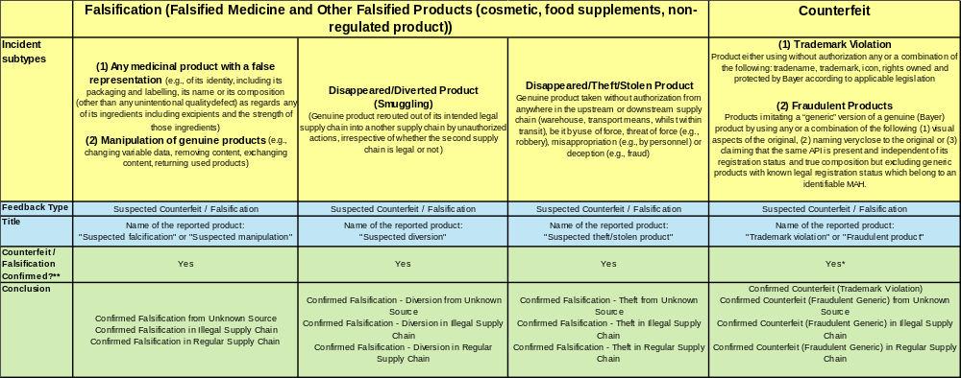

* For Trademark Violations, where it is known that the reported incident does not refer to a Bayer product, assessment is performed by GBS/CQU
**Cases reported as "suspected falsification / counterfeit" and assessed to be genuine/registered product follow regular PTC process

Annex 3: Decision tree for handling complaint samples
